Student Performance Analytics System - Project Documentation

1. Project Title
Student Performance Analytics System

👤 Name: Ayush Sharma

🏫 College: Vaish College of Engineering

💻 Internship Domain: Python with AI

👨‍🏫 Trainer: Chandini Mam
2. Objective
The goal of this project was to build a small Python program that can take the records of a group of students and turn them into useful results. A teacher looking at raw marks in a file cannot easily say who is doing well, which subject is weak or how many students have failed. This program does that work automatically.
The project also helped me practise the topics covered in class: variables, data types, loops, functions, NumPy and Pandas. No machine learning is used. Everything is done with basic Python and simple calculations.

3. Technologies Used
- Python 3 for the main program, loops and functions
- NumPy for totals, averages, highest and lowest values
- Pandas for loading the CSV file and working with the DataFrame
- Matplotlib for the charts in the Jupyter Notebook
- Jupyter Notebook for the step-by-step analysis
- HTML and CSS for the result web page
- Git and GitHub for storing the project
- GitHub Pages for the live link

4. Dataset Description
The dataset is a CSV file called students.csv with 60 student records. It is sample data that I created for this project, with realistic names, marks and attendance values. It does not belong to real students.
Column | Meaning
Student_ID | Unique ID of the student (1001 to 1060)
Name | Name of the student
Department | CSE, ECE, ME, CE or IT
Maths | Marks out of 100
Physics | Marks out of 100
Chemistry | Marks out of 100
English | Marks out of 100
Computer | Marks out of 100
Attendance | Attendance percentage
The dataset has 60 rows and 9 columns, and there are no missing values.

5. Implementation
The project is split into three Python files. main.py runs everything, functions.py has the calculation functions and report.py builds the web page. The steps are as follows.
- Dataset: I created students.csv with 60 student records.
- Loading data: The function load_data() reads the file with pd.read_csv(). I then printed the number of rows and columns, the column names, the first few rows and the count of missing values.
- Total and average: The five subject columns are converted to a NumPy array. np.sum() and np.mean() with axis=1 give the total and average for every student.
- Grades: The function get_grade() uses if/elif conditions on the average marks. A loop in assign_grades() goes through every average and stores the grade.
- Pass or Fail: The function get_result() checks all five subjects. If any subject is below 40, the student fails. A loop in assign_results() applies this to every row.
- Attendance: np.where() marks students below 75% attendance as Shortage.
- Class summary: NumPy functions (np.mean, np.max, np.min, np.sum) give the class average, highest and lowest average, and the number of passed and failed students.
- Subject-wise analysis: A loop goes through each subject and finds its average, highest, lowest and pass/fail count.
- Department-wise analysis: Pandas groupby() gives the average marks, average attendance and passed students for each department.
- Top performers: sort_values() and head(5) give the top 5 students by average marks.
- Output: Results are printed in the terminal, saved to results.csv and written into docs/index.html. The notebook shows the same analysis with charts.
Grading and pass rules used in the project:
Average marks | Grade
90 and above | A+
80 to 89 | A
70 to 79 | B
60 to 69 | C
50 to 59 | D
40 to 49 | E
Below 40 | F
Pass condition: at least 40 marks in every subject. Attendance below 75% is marked as shortage.

6. Key Features
- load_data() reads the student CSV into a Pandas DataFrame
- calculate_total_and_average() finds total and average marks using NumPy
- get_grade() and assign_grades() give every student a grade based on a clear rule
- get_result() and assign_results() decide Pass or Fail
- attendance_status() flags students with attendance below 75%
- class_summary() gives class average, highest, lowest, pass count and pass percentage
- subject_analysis() gives subject-wise average, highest, lowest and pass/fail count
- department_analysis() compares the departments
- grade_distribution() counts how many students got each grade
- top_performers() lists the top 5 students
- A result web page with cards, bars and a search box, published with GitHub Pages
- A Jupyter Notebook with the full analysis and charts

7. Output / Screenshots

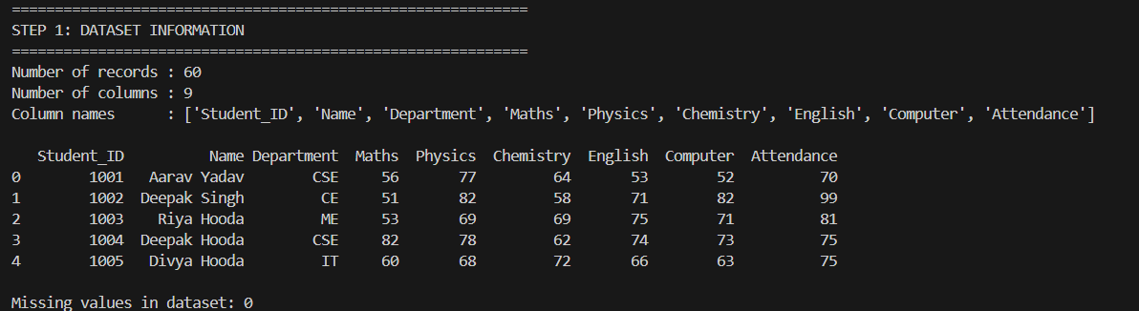

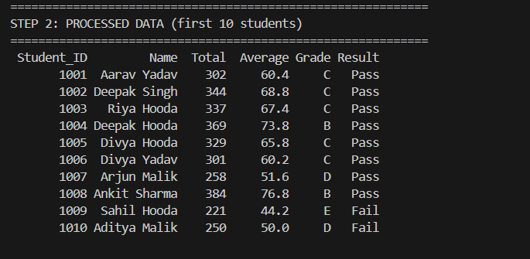

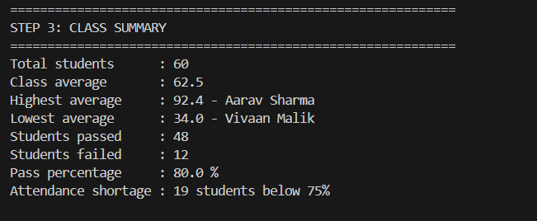

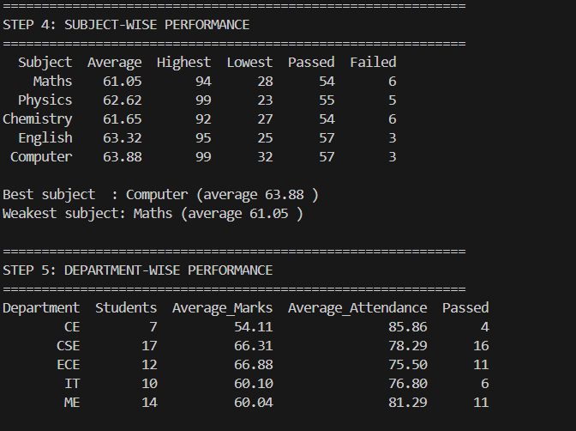

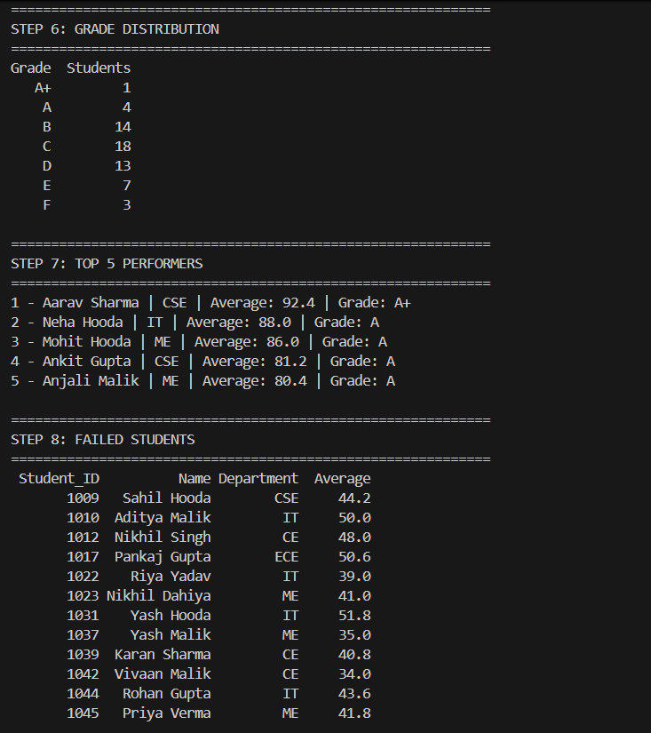

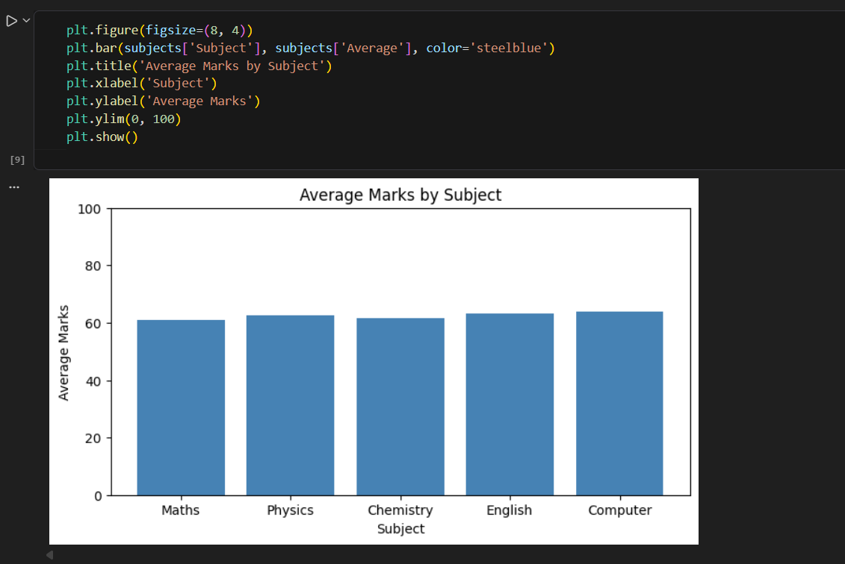

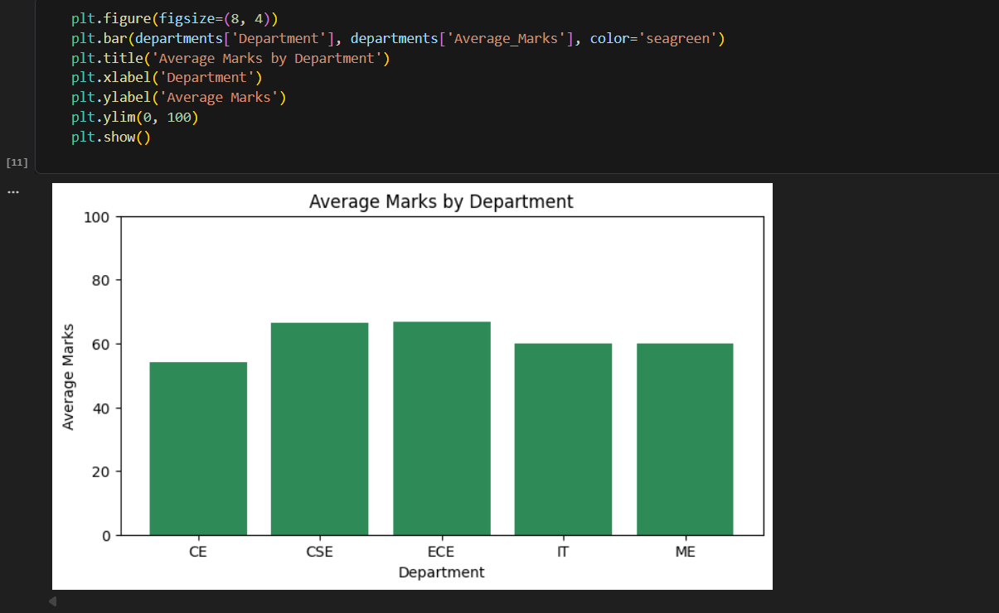

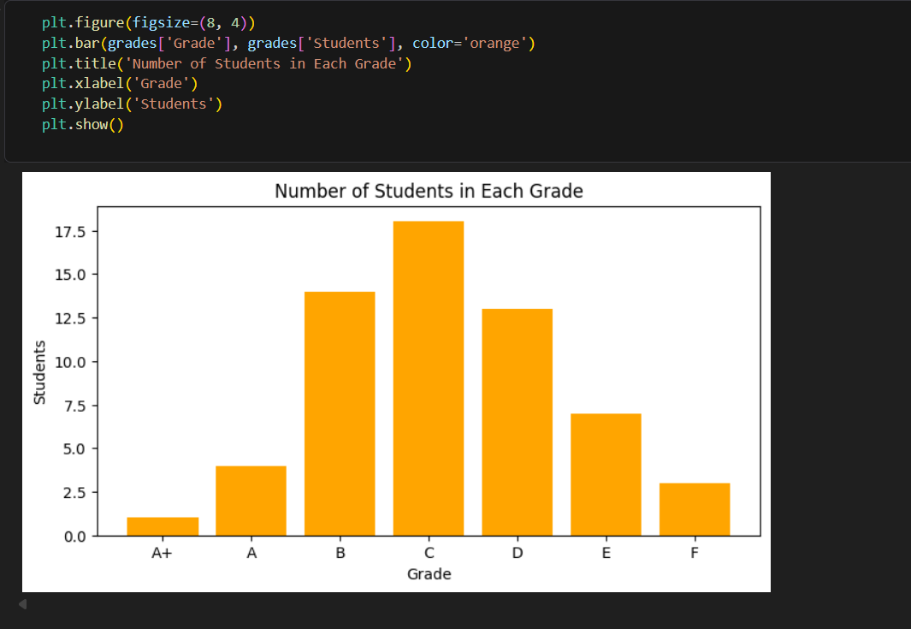

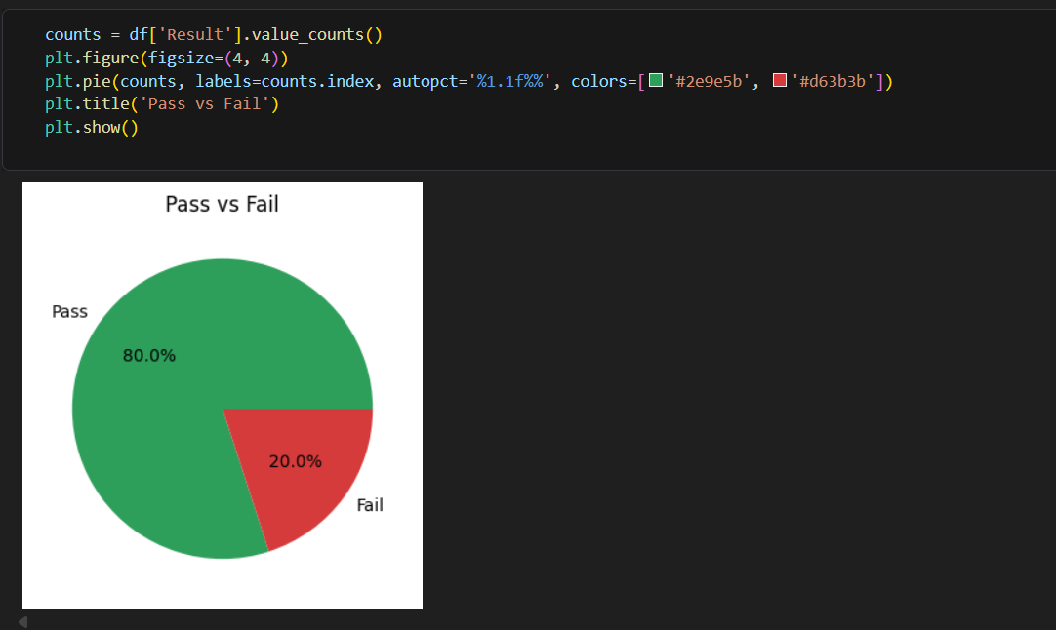

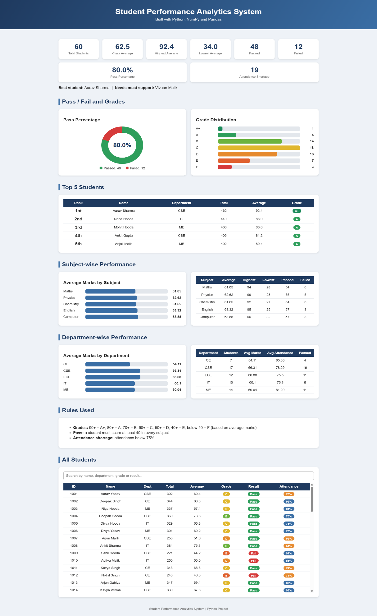

8. Final Outcome
The project works from start to finish. It reads the 60 student records, calculates everything and shows the results in the terminal, in the notebook and on a live web page. These are the main results:
- Class average is 62.5 marks
- 48 students passed and 12 failed, so the pass percentage is 80%
- Highest average is 92.4 (Aarav Sharma, CSE) and the lowest is 34.0 (Vivaan Malik, CE)
- Computer is the best subject with an average of 63.88, and Maths is the weakest with 61.05
- ECE has the highest department average (66.88) and CE has the lowest (54.11)
- 19 students have attendance below 75%
- Most students got grade C (18) or B (14), and only 1 student got A+
The output is easy to understand without opening the code, which was one of the main requirements. The project uses only basic Python, NumPy and Pandas.

9. Challenges & Learning
Challenges
- Deciding the pass rule. At first I thought of using only the average marks, but then a student could fail a subject and still pass. I changed it so that a student must score at least 40 in every subject.
- Mixing Pandas and NumPy. I was not sure when to use which one. I solved it by using Pandas to load and group the data, and NumPy for the calculations on the marks.
- Showing the results online. A terminal output cannot be shared as a link, so I made an HTML page from the results and published it with GitHub Pages from the docs folder.
- Keeping the code simple. I used plain loops and if/else conditions instead of shortcuts so that every step is easy to follow.
Learning
- How to load a CSV file and work with a DataFrame
- How NumPy functions with axis work on rows and columns
- Why splitting code into reusable functions makes it cleaner
- How to use groupby() and sort_values() for analysis
- How to push a project to GitHub and publish it with GitHub Pages

10. GitHub Repository
Repository: https://github.com/ayush-cyber1/student-performance-analytics
Live page: https://ayush-cyber1.github.io/student-performance-analytics/

